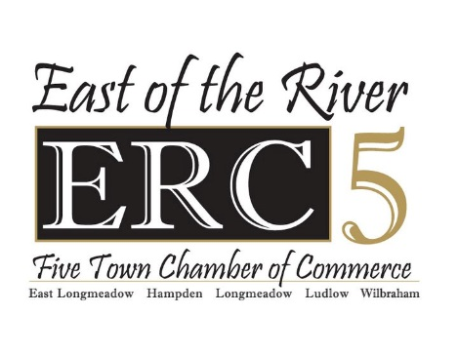

Class of 2024

Dear High School Senior and Parents:
The purpose of the ERC5 Scholarship is to promote the attainment of higher education for graduating seniors who reside within the ERC5 footprint. The East of the River Chamber of Commerce (ERC5) includes East Longmeadow, Longmeadow, Hampden, Wilbraham, and Ludlow. A $1000.00 scholarship is awarded to two graduating seniors from each Town’s high school.
Applicants must have completed at least one business focused class during high school. In addition, graduating seniors must be planning to attend an accredited college, technical school or certification program. Scholarship awards will be based on the applicant’s academic performance, extracurricular activities that you have participated in during school, after school, work experience, music/arts and/or sports programs.
The application must be typed and completed to be accepted for consideration.
Please return the completed application and required supporting documents to the ERC5 Offices at 280 N. Main Street, Suite 2 East Longmeadow or send electronically to gbarone@erc5.com by March 29, 2024. If you have any questions, please contact Grace Barone at (413) 575-7230
Thank you for your application and good luck!

Grace Barone
ERC5 Executive Director
280 N. Main Street, Suite 2
East Longmeadow, MA 01028
(413) 575-7230
gbarone@erc5.com
www.erc5.com

ERC5 SCHOLARSHIP APPLICATION
CLASS OF 2024

Name: ____________________________________________________________ Date: ______________

Address: ____________________________________________________TOWN: __________________

Applicant’s e-mail address: ______________________________________________________________

Home Phone: _____________________________________ Cell Phone: __________________________

Parents/Guardians: ____________________________________________________________________

Parent’s/Guardian’s e-mail address: _______________________________________________________

What is your intended field of study? ______________________________________________________

Schools Honors and Awards: ____________________________________________________________________________________________________________________________________________________________________________________________________________________________________________________________________________________________________________________________________________________

Activities:

Clubs/Organizations:
_______________________________________________________________________________________________________________________________________________________________________________________________________________________________________________________________
_____________________________________________________________________________________

Community Service:
____________________________________________________________________________________________________________________________________________________________________________________________________________________________________________________________________________________________________________________________________________________

Athletic Activities:
____________________________________________________________________________________________________________________________________________________________________________________________________________________________________________________________________________________________________________________________________________________

Music/Arts:
____________________________________________________________________________________________________________________________________________________________________________________________________________________________________________________________________________________________________________________________________________________

Work Experience: During school and/or summer (type and dates)
____________________________________________________________________________________________________________________________________________________________________________________________________________________________________________________________________________________________________________________________________________________

PLEASE THINK ABOUT THE FOLLOWING QUESTIONS AND BRIEFLY ANSWER EACH ONE.
- What is your future career and why did you choose this career?
______________________________________________________________________________________________________________________________________________________________________________________________________________________________________________________________________________________________________________________________________________________________________________________________________________________________________________________________________________________________________________________________________________________________________________________________________________________________________________________________________________________________________________________________

- Describe your goals as they relate to your education?
______________________________________________________________________________________________________________________________________________________________________________________________________________________________________________________________________________________________________________________________________________________________________________________________________________________________________________________________________________________________________________________________________________________________________________________________________________________________________________________________________________________________________________________________

- What was the business focused class you participated in during high school and what is one thing you learned from the class?
____________________________________________________________________________________________________________________________________________________________________________________________________________________________________________________________________________________________________________________________________________________________________________________________________________________________________________________________________________________

ERC5 SCHOLARSHIP APPLICATION CHECKLIST

Before returning this application to your high school guidance office on or before March 29, 2024, please be sure you have included all of the following:

________ TYPED AND COMPLETED student application form.

________ Official transcript – students MUST obtain from the guidance office.

________ Recommendations – counselor/teacher/coach/employer, etc.

________ All applications & supporting documentation must be returned to the ERC5 Offices at 280 N. Main Street, Suite 2 East Longmeadow or send electronically to gbarone@erc5.com no later than March 29, 2024

ONLY COMPLETE APPLICATIONS WILL BE ACCEPTED.
DEADLINE FOR ACCEPTANCE: March 29, 2024

